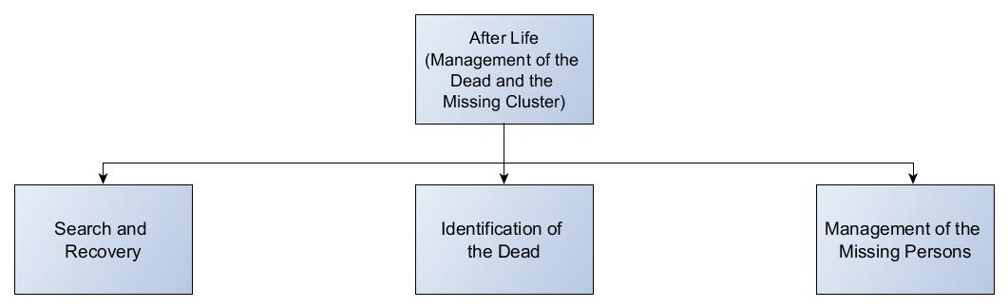

**Introduction**

The Philippines, in the past few months, had been a victim to different major disasters which have claimed thousands of innocent lives. Mostly, the government relies on the response to help those who are in need. During disasters, the main problem that comes to mind is how do we give food and shelter to those who are affected, while that might be a difficult task and a major problem, management of the dead is also one of the most challenging task in disaster management.

People sometimes have trouble appealing to authorities about their missing or dead loved ones. Reporting and identification of people are the very essential part of managing the dead and the missing. This app aims to have a standardized way of reporting and identifying people.

**Description**

After Life is a system intended to help the agencies under NDRRMC who are in charge of the Management of the Dead and the Missing. It will help by automating all the data that will be gathered, reducing all the paper works included in the process. After Life includes many different forms that user can fill-up to cater their needs, an example would be submitting information about a missing person, submitting information about a dead person, or aspiring to be a volunteer.

**Objectives**

**General**

To provide a system to help the cluster have an efficient and a well-coordinated action in managing the dead and the missing persons during emergencies and disasters

**Specific**

* To help identify people and announce their status by having an in-application list of all the entries of dead and missing persons.
* To easily monitor all data about the dead and missing persons by having an automated system of storing and retrieval of data
* To help the cluster have an organized search operations by using the data seen on the application that are submitted by different users

**Functions**

1. Sign-up
2. Log-in
3. Missing Person list searching
4. Dead Person list searching
5. Filling-up Dead Person Form
6. Filling-up Missing Person Form
7. Filling-up Volunteer Form
8. Data Validation
9. Searching for near makeshift morgues
10. Request for dead bodies transportation
11. Dead and Missing data matching
12. Data summarization (analytics)
13. Logout

**Features**

* Volunteers’ List and Form Inclusion
* Proper Body Handling Manual
* Summary of the Dead and Missing Statistics (Analytics)
* Site News
* Matchmaking of Data
* List of Makeshift Morgue
* Transportation Request